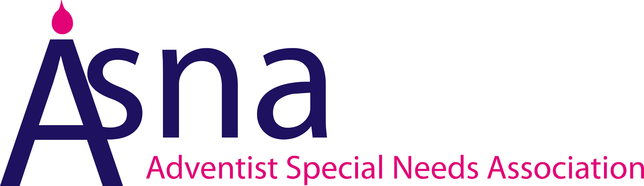

Adventist Special Needs Association (ASNA)
Health and Safety Policy

This policy is written in accordance with the Health and Safety at Work Act 1974.

ASNA was launched as an association in 2001 and registered as a charity in November 2003.
ASNA currently has eight trustees, three admin volunteers, a team of Carer Support volunteers, a team of freelance workshop and conference leaders, a team of volunteer diversity champions and a team of volunteer carer advocates.

ASNA intends to meet its legal obligations by providing and maintaining a safe and healthy working environment so far as is reasonably practicable. This will be achieved by;
- providing leadership and adequate control of identified health and safety risks;
- consulting with our volunteers and employers on matters affecting their health and safety;
- providing and maintaining safe equipment;
- ensuring the safe handling and use of substances;
- providing information, instruction, training where necessary for our workforce, taking account of any who do not have English as a first language;
- ensuring that all workers are competent to do their work, and giving them appropriate training;
- preventing accidents and cases of work-related ill health;
- actively managing and supervising health and safety at work;
- having access to competent advice;
- aiming for continuous improvement in our health and safety performance and management through regular (at least annual) review and revision of this policy; and
- the provision of the resource required to make this policy and our health and safety arrangements effective
We also recognise;
- our duty to co-operate and work with other employers when we work at premises or sites under their control to ensure the continued health and safety of all those at work; and
- our duty to co-operate and work with other employers and their workers, when their workers come onto our premises or sites to do work for us, to ensure the health and safety of everyone at work. To help achieve our objectives and ensure our employees recognise their duties under health and safety legislation whilst at work, we will also remind them of their duty to take reasonable care for themselves and for others who might be affected by their activities.
Health and Safety Responsibilities
1. Overall responsibility for the health and safety of employees, clients, contractors and visitors is that of ASNA Trustee Board.
2. Day-to-day responsibility for ensuring this policy is put into practice is delegated to the CEO / Director General and Operations manager.
3. To ensure that health and safety standards are maintained in priority areas their responsibilities include:
- Risk assessments. Identify significant hazards at the workplace and carry out and record risk assessments in consultation with team members and trustees, and review as often as is appropriate;
- Implementation of safety measures. To inform and train team members as necessary to ensure implementation of, and compliance with, safety measures that are identified by risk assessments;
- Reporting of accidents and ill-health. To record all accidents that occur to team members, clients, visitors, contractors, etc., and notify all relevant accidents/incidents, diseases and dangerous occurrences to the enforcing authorities’ incident centre, as required under RIDDOR;
- Inclusion in health and safety procedures in other premises visited: When confirming team members bookings at other premises, to include a reminder of the need to inform our visiting team members of relevant health and safety procedures at the premises.
4. ASNA team members, freelance workers and volunteers are required to:
- co-operate with the Director General and Operations manager on all health and safety matters;
- not interfere with anything provided to safeguard their health and safety;
- take reasonable care of their own health and safety at work and the health and safety of others with whom they are involved;
- advise and inform persons responsible on premises where work is carried out, other than that of ASNA, of any health and safety concerns they may have;
- report all health and safety concerns to the Director General and of Operations manager.
Health and Safety Risks arising from our work activities
1. The Operations Manger will undertake risk assessments, in consultation with the team members involved, and with interested trustees and health and safety experts, in the following specific areas:
- Safety in team members’ homes when working from home
- Safety in ASNA storerooms and when handling equipment;
- Manual handling of ASNA musical and other equipment;
- Music Practitioners activities, including transport and other matters affecting personal safety;
- Working with display screen equipment;
- Activities involving children or adults with disabilities held in schools, homes and external settings
2. If other significant health and safety hazards are identified, the Operations manager will undertake risk assessments as necessary.
3. Findings of risk assessments will be reported to the trustees.
4. Action recommended to eliminate or to control risks will be approved by the Director General / Operations manager (OM).
5. The Director General / OM will be responsible for ensuring implementation of the action required.
6. When relevant, an item on health and safety will be included in meetings of the trustees who will check that the implemented actions are effective.
7. Assessments will be reviewed at least annually or when significant changes occur.
Consultation with Team members
1. All team members involved will be consulted directly by the CEO/OM on the risk assessments and the action proposed to reduce risk.
Safety with Equipment
1. The music practitioners / workshop leaders will be responsible for identifying any musical equipment needing maintenance, through day-to-day visual checks, and reporting this to the Operations manager
2. The Operations manager will be responsible for ensuring that all maintenance is carried out.
3. The Operations manager will be responsible for ensuring that relevant portable electrical equipment is tested regularly by a competent person in accordance with HSE published guidance on portable electrical equipment in offices or low-risk environments.
4. The Operations manager will be responsible for ensuring that new equipment meets current health and safety standards before it is purchased.
Information, Instruction and Supervision
1. Copies of this Health and Safety Policy Statement and of associated risk assessments and guidance will be given to all employees, freelance team members and volunteers
2. Health and Safety information will be accessible from the CEO/Director of Operations.
3. The Operations manager will arrange for supervision of any new team members as necessary.
4. The Operations manager will be responsible for ensuring that our team working at locations not under ASNA control are given relevant health and safety information.
Competency for Tasks and Training
The CEO/Director of Operations will be responsible for ensuring that current and relevant information on health and safety is included in all ASNA team members training courses both for new and existing team members and volunteers.
Accidents, First Aid and Work-related ill health
1. The Operations manager will ensure that team members visiting schools can make use of local first-aid facilities if necessary.
2. When out and about on ASNA work, team members are required to be in possession of a mobile phone to enable them to request help if necessary, and to keep a basic first-aid kit in their vehicle.
5. Team members are required to record all accidents, including road accidents where they suffer injury, even minor injuries, or cases of work-related ill health sustained by them, and to report these to the CEO/Director of Operations, within 24 hours. The accident can be recorded in the ASNA accident book. If the accident occurs on other premises it should also be reported to the organisation concerned and recorded in its accident book.
6. The CEO and Operations manager will ensure that all accident reports are investigated as necessary and reported to the trustees.
7. The CEO/Director of Operations is responsible for reporting relevant accidents, diseases or dangerous occurrences to the enforcing authority incident centre, as required under RIDDOR.
Monitoring
1. If there are any accidents or work-related ill-health, the CEO/Director of Operations is responsible for investigating them and recommending action to avoid a recurrence.
2. When relevant, an item on health and safety will be included in meetings of the trustees, who will check that safe working practices are being followed. They will also review this policy statement in the light of experience each year.

Emergency Procedures- fire and evacuation
1. All ASNA team members must know the action to take if they discover a fire or hear the alarm in any premises. Those working from home, must have a fire and evacuation plan.
2. At other premises, ASNA team members are required to familiarise themselves with the fire safety arrangements and procedures for the premises, and to be aware of the location of fire-fighting equipment, escape routes and precautions to take, as above.

Policies that work alongside this policy

Risk Assessment
Working from Home Risk Assessment
Policy for Online Safety
Safeguarding Policy

Policy revised December 2020 by ASNA Director General – Sophia Nicholls MSc, MA, PGCert (Disability and Inclusion)

ASNA office,
Alma Park Estate,
Grantham,
Lincolnshire,
NG31 9SL.
Telephone: 01476 591 700

