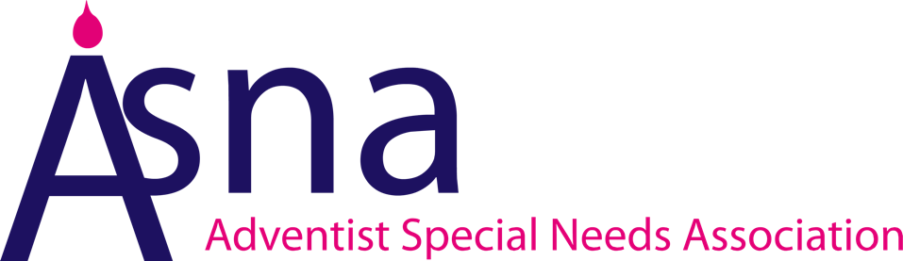

Equality and Diversity Policy
Contents:
- Our aim
- About our policy
- Our responsibilities
- Our commitments
- Working with contractors, suppliers and partners
- Review and Action

Appendices
Appendix A: Equality Act 2010 - Explanation of the Protected Characteristics

- Our aim

1.1 In carrying out its functions as a charity, ASNA is committed to promoting equality of opportunity for all and to ensuring that no individual is discriminated against in the planning and delivery of any of our activities.
1.2 We therefore aim to ensure that the values of equality, diversity and respect for all are embedded into everything that we do.

- About our policy

2.1 This policy is intended to demonstrate ASNA’s commitment to eliminating discrimination and encouraging and valuing diversity among staff, volunteers, partners, suppliers, users of our services and trustees.
2.2 We recognise our responsibilities under the Equality Act 2010 and are committed to meeting them in full. We believe that a culture that embraces equality and values diversity will help us to ensure that everyone feels involved and included in our plans, programmes and activities.
2.3 We aim to create an environment which respects and welcomes everyone, and in which no form of bullying, harassment, disrespectful or discriminatory behaviour is tolerated by anyone towards anyone. This particularly applies in relation to the ‘protected characteristics’ named in the Equality Act 2010:
If the organisation delivers services for public authorities, they should be aware of the requirements of the Public Sector Equality Duty and be guided by its three ‘aims’.
Age, disability, gender reassignment, income, marriage or civil partnership status, pregnancy and maternity, race, religion or belief, sex and sexual orientation, (see below for explanations).

- Our responsibilities

3.1 ASNA understands that for equality to be achieved this policy needs to be made understandable to, and embraced by staff, volunteers, suppliers, partners, residents and trustees.
3.2 This policy will be subject to agreement with any trade union, which staff choose to join or to which they belong. The policy is fully supported and welcomed by all employees and has been agreed by our Board of Trustees.
3.3 All staff, volunteers, suppliers, partners and trustees have a responsibility to ensure that their own language and actions are consistent with the spirit as well as the contents of this policy.
3.4 Overall responsibility for the implementation of this policy lies with ASNA’s DG and its trustees.

- Our commitments

4.1 ASNA recognises that an Equality and Diversity Policy alone is not enough to ensure that equality and diversity are central to everything that we do.
4.2 We will seek to create an environment in which diversity and the contributions of all staff, volunteers, suppliers, partners, residents and trustees are recognised and valued in all that we do. In this way, we hope to provide an example of good equality practice and promote community cohesion within ASNA.
4.3 In introducing this policy we recognise that many people are unfamiliar with the ways in which discrimination and disadvantage affect people’s health, well-being and quality of life. We will therefore support people to develop equalities awareness and understanding.
4.4 To ensure that we are meeting the aims and the spirit of this policy we will:

a) Discuss and review how well we are implementing this policy, and (adjust our practices/develop an action plan) where necessary

b) Assess any significant new or revised policies and procedures for their impact on equality

c) Embed equality and diversity into our development plans
d) Ensure our employment practices and procedures are consistent with the aims of this policy.

- Working with contractors, suppliers and partners

It is important to us that suppliers, contractors and any other individual or organisation working on behalf of ASNA are aware of and agree to comply with our equality and diversity policy while that work is underway. In addition, we are committed to:
- using accessible venues for events and meetings;
- using plain English, and offering accessible communications,

For example, emails, letters, reports and publicity materials as far as it is within our means to do so.

- Review and Action

6.1 We recognise that it is important for us to regularly review this policy to ensure that it reflects up to date equality legislation and best practice.
6.2 A review of our Equality and Diversity Policy will be carried out on a bi-annual basis as a minimum and any necessary actions taken.
(Note 14pt sans fonts, such as Tahoma, and right justified margins are the easiest for people with visual impairments. Tinted paper is helpful for people with dyslexia)

This Policy was written in December 2020

ASNA office, Alma Park Estate, Grantham, Lincolnshire, NG31 9SL. Telephone: 01476 591 700
Appendix A:
Equality Act 2010 - Explanation of the Protected Characteristics
It is against the law to discriminate against someone because of the following protected characteristics:

- age
- disability
- gender reassignment
- marriage and civil partnership
- pregnancy and maternity
- race
- religion or belief
- sex
- sexual orientation

You are protected under the Equality Act 2010 from these types of discrimination.

Age | A person belonging to a particular age (for example 32 year olds) or range of ages (for example 18 to 30 year olds).
Disability | A person with a physical or mental impairment that has a 'substantial' and 'long-term' negative effect on their ability to do normal daily activities
Gender reassignment | The process of transitioning from one gender to another.
Marriage and civil partnership | Marriage is a union between a man and a woman or between a same-sex couple. Civil partners must not be treated less favourably than married couples (except where permitted by the Equality Act).
Pregnancy and maternity | Pregnancy is the condition of being pregnant or expecting a baby. Maternity refers to the period after the birth, and is linked to maternity leave in the employment context. In the non-work context, protection against maternity discrimination is for 26 weeks after giving birth, and this includes treating a woman unfavourably because she is breastfeeding.
Race | Refers to the protected characteristic of race. It refers to a group of people defined by their race, colour, and nationality (including citizenship) ethnic or national origins.
Religion and belief | Religion refers to any religion, including a lack of religion. Belief refers to any religious or philosophical belief and includes a lack of belief. Generally, a belief should affect your life choices or the way you live for it to be included in the definition.
Sex | A man or a woman.
Sexual orientation | Whether a person's sexual attraction is towards their own sex, the opposite sex or to both sexes.

Source: Equality and Human Rights Commission:
www.equalityhumanrights.com/en/equality-act/protected-characteristics

