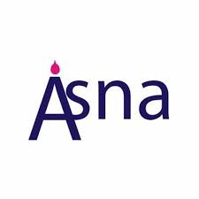
Belonging Reflection Tool
Although individuals can use this reflection tool, it is designed for collaborative reflection. To the greatest extent possible, talk with and listen to others at your church (e.g., teachers, related service providers, paraprofessionals, families, members with and without disabilities). For each of the ten dimensions of belonging, reflect on what you are doing well and what could be done better or differently. To ensure this reflection leads to observable action, agree on taking at least three actionable steps that will make a noticeable difference in promoting belonging at your church.
Dimensions of belonging | What are we doing  really well right now in this area? | What could we be doing  better or differently in this area?
Present
Are disabled members involved in all of the same spaces and activities as their peers?
Invited
Is the presence and participation of members with disability actively sought out and encouraged by others at their church?
Welcomed
Are members with special needs received by others at the church with warmth, friendliness, and authentic delight?
Known
Are members viewed as unique individuals, recognised by their strengths, and appreciated for who they are?
Accepted
Are members embraced without condition and viewed as equals by their peers?
Involved
Are members with special needs actively engaged with their peers in shared learning and common goals?
Supported
Are members with special needs given what they need to reach their full potential and truly thrive?
Heard
Are the perspectives of each student sought out, listened to, and respected by others?
Befriended
Have members developed relationships with their peers that are marked by mutual affection and reciprocity?
Needed
Are members with special needs valued by others and considered to be indispensable members of the church community?

Next Steps
What actionable steps should we take next to ensure all students experience belonging in our school?

Adapted from: Carter, E. W. (2020, November). From barriers to belonging: Creating inclusive communities for everyone.
Keynote presentation at the International OCALICON Conference.
ASNA is a registered Charity 1100447
www.asna.info
info@asna.info

